
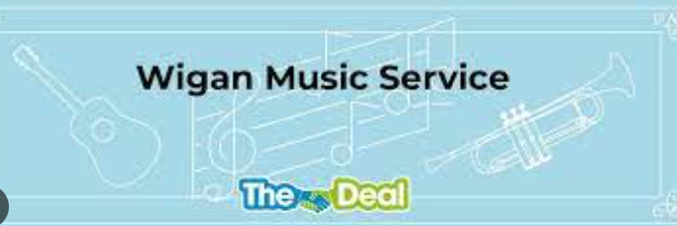
Brass lessons are provided by wider opportunities for Year 4.
A number of children throughout the school, from Y1 – Y6, have weekly music lessons provided by peripatetic teachers from Wigan Music Service. These include: recorder, drums, singing, piano and guitar.

Children have the opportunity to improvise and compose using different instruments.
The Key Stage 2 choir meet weekly to learn and practise songs, new and those already familiar, with a range of themes. A weekly singing assembly allows children from all classes to learn a variety of songs throughout the year.

Musical vocabulary is integrated as part of every lesson.
Music is further integrated into our school by children listening to a wide variety of music genres either in class or during daily assemblies. They learn a variety of songs for different celebrations throughout the year. Furthermore, each week, a new composer is introduced to the children.

Music is taught primarily through the Charanga Musical School Scheme which provides clear progression, lesson by lesson, engaging and exciting whiteboard resources to support every lesson, although staff are encouraged to add their own influence where appropriate. This is achieved by structuring all music lessons into three parts: listening and appraising a variety of genres and composers over time, creating and exploring through musical activities, where children are encouraged to use their time wisely to rehearse and embrace new experiences, and performing and sharing.
Implementation – How do we aim to deliver it?
Pupil voice shows that children enjoy the range of music genres they listen to and songs they learn.
• Take part in performances with an awareness of audience.

• Use a range of musical language.
• Make judgements and express personal preferences about the quality and style of music.

• Can sing and use their voices to create different effects.
• Create and compose music, both on their own and with others.

- Enjoy and have an appreciation for music.
• Listen to, review and evaluate music across a range of historical periods, genres, cultures, styles and traditions.

Intent – What we aim to deliver
Children are able to make links between new music and music they have heard before.
Children are able to confidently perform in front of an audience and express their thoughts about different pieces of music.
The majority of children in each year group are working at or above ARE for their age.

Impact – How will we know we have delivered it?
Music teaching at Gilded Hollins aims to follow the specifications of the National Curriculum; providing a broad, balanced and differentiated curriculum and ensuring the progressive development of musical concepts, knowledge and skills. At Gilded Hollins we believe that music plays an integral role in helping children to feel part of a community, therefore we provide opportunities for all children to create, play, perform and enjoy music both in class and to an audience.

