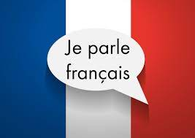
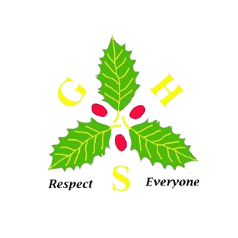


To provide a curriculum that enables children learning French to progress within each academic year and throughout KS2.
To develop, for all children, a genuine interest and positive curiosity about foreign languages, finding them enjoyable and stimulating.
To develop the four key learning skills: listening, speaking, reading and writing in each unit across KS2 with increasing complexity.
To enable opportunities to explore relationships between language and identity and to develop a deeper understanding of other cultures
Implementation – How do we aim to deliver it?

Whole school ethos
Through whole school culture and language days; strategies such as simple signs in French and identifying those who speak or hear a second language at home we aim to positively raise the profile of languages across Gilded Hollins.
Impact – How will we know we have delivered it?

Language Angels
The basis of our teaching is taken from the Language Angels French scheme. Language learning skills are carefully planned for with units selected to ensure progression within an academic year and across the KS2 phase. Units increase in level of linguistic and grammatical complexity as children move from Early Learning units through Intermediate units and into Progressive units. Units in each subsequent level require more knowledge and application of skills than the previous. Activities contain progressively more text (both in English and French) and lessons will have more content as the children become more confident and ambitious.

KS2 Curriculum
Children will progressively acquire, use and apply a growing bank of vocabulary, language skills and grammatical knowledge organised around age-appropriate topics and themes - building blocks of language into more complex, fluent and authentic language.
A clear Progression Map ensures all children are progressing their French learning skills and are taught the appropriate grammar at the right time in their French learning journey.
Vocabulary lists
Children will be provided with a vocabulary list for each unit. These will be referred to throughout their French lessons and will be actively used and encouraged as a learning tool. In addition, the children will be taught how to look up and research language they are unsure of.

Enrichment days such as European Languages Day and Francophone Culture Day are accessed by all children.
Children’s progress identified through self assessment and summative assessment for each unit.
Intent – What do we aim to deliver?

Pupils show enthusiasm towards French, and other languages, and have a deeper understanding of other cultures.
The majority of children in each year group are working at or above ARE for their age.

At Gilded Hollins, we aim to offer a relevant and ambitious foreign languages curriculum that will inspire and excite our children using a variety of topics and themes. The children will develop a better awareness of self, others and cultural similarities and differences. We intend to give children the language foundations to become life-long language learners.

