Pupil Premium Strategy Statement – 2024-2025
This statement details our school’s use of pupil premium for the current academic year to help improve the attainment of our disadvantaged pupils.
It outlines our pupil premium strategy, how we intend to spend the funding in this academic year and the effect that last year’s spending of pupil premium had within our school.

School overview
Detail | Data
School name | Gilded Hollins Primary
Number of pupils in school | 212
Proportion (%) of pupil premium eligible pupils | 7%
Academic year/years that our current pupil premium strategy plan covers (3 year plans are recommended) | 2022 - 2025
Date this statement was published | September 2024
Date on which it will be reviewed | September 2025
Statement authorised by | C Burns, Headteacher
Pupil premium lead | C Burns, Headteacher
Governor / Trustee lead | R Hampson, Chair of Governors

Funding overview
Detail | Amount
Pupil premium funding allocation this academic year | £29,840
Recovery premium funding allocation this academic year | £653
Pupil premium funding carried forward from previous years (enter £0 if not applicable) | £0
Total budget for this academic year  If your school is an academy in a trust that pools this funding, state the amount available to your school this academic year | £ 30,493

Part A: Pupil premium strategy plan

Statement of intent
At Gilded Hollins, we intend that all children, irrespective of their background or the challenges they face, make good progress and achieve highly across all subject areas. The focus of our pupil premium strategy is to support disadvantaged pupils to achieve that goal, including progress for those who are already high attainers.
Quality first teaching is at the heart of our approach, with a focus on areas in which disadvantaged pupils require the most support. This is proven to have the greatest impact on closing the disadvantage attainment gap and at the same time will benefit the non-disadvantaged pupils in our school. Implicit in the intended outcomes detailed below, is the intention that non-disadvantaged pupils’ attainment will be sustained and improved alongside progress for their disadvantaged peers.
We will consider the challenges faced by all our vulnerable pupils, such as those who are looked after or who have a social worker. The activities we have outlined in this statement is also intended to support their needs, regardless of whether they are disadvantaged or not.
We expect all staff take responsibility for disadvantaged pupils’ outcomes and raise expectations of what they can achieve, with a whole school ‘can do ‘approach.
The approaches we have adopted complement each other to help pupils excel. To ensure they are effective we will:
- ensure disadvantaged pupils are challenged in the work that they’re set
- act early to intervene and provide support at the point need is identified

Challenges
This details the key challenges to achievement that we have identified among our disadvantaged pupils.
Challenge number | Detail of challenge
1 | Poor language acquisition due to limited experiences in early childhood and beyond. Some children have a limited vocabulary, compounded by a narrowed reading diet. They struggle to comprehend the more complex aspects of the written word. This in turn, impacts upon their written work.
2 | Certain children struggle with applying the mathematical concepts needed to tackle more complex mathematical activities due to their grasp of language
3 | Financial difficulties for some families may prevent children accessing activities or taking part in extracurricular activities
4 | Lack of self-confidence, limited perseverance and resilience are factors that affect several children.

Intended outcomes
This explains the outcomes we are aiming for by the end of our current strategy plan, and how we will measure whether they have been achieved.

Intended outcome | Success criteria
Every child has access to the highest quality teaching. | Progress and attainment of pupils eligible for pupil premium and those not eligible is consistently in line with ,or above, national expectation.
Increased vocabulary in order to access the curriculum and achieve well across a broad range of subjects as measured by their attainment and achievement and pupil voice feedback. | Children read more widely, have a love of the written word, and achieve in line with national comparators in reading and writing.
All children are enabled to take part in wide, broad life experiences. | PPG children are enabled to take part in after school clubs, music lessons, and any other activities that will widen their life experiences.
Children present in school with positive attitudes  and immerse themselves in curriculum experiences | Children have high engagement in school activities.  Children demonstrate increased resilience, self- belief and self-confidence.
Flexible, timely, targeted interventions are put in place as soon as they are needed. | Children feel supported in their learning. Gaps in learning are closed quickly.

Activity in this academic year
This details how we intend to spend our pupil premium funding this academic year to address the challenges listed above.
The cost of these strategies to improve the outcome for our disadvantaged children totals far more than our Pupil Premium Grant allocation. Because of this, spending outlined below may supersede our Pupil Premium Grant.

Teaching
Budgeted cost: £3,500 + £5,000 = £8,500

Activity | Evidence that supports this approach | Challenge number(s) addressed
Partnership with the Northwest  Teaching Hub, LLG and access to the National College to provide bespoke, targeted CPD for all staff.  £3,500 | EEF toolkit – Metacognition and SelfRegulation Strategies. +7 months impact  Supporting the attainment of disadvantaged pupils - Briefing for School Leaders.  November 2015 | 1,2,4
Following on from the introduction of RWInc, continue to enhance our reading provision for children.  £5,000 | EEF Toolkit – Phonics – 5+ months  EEF Toolkit – Reading Comprehension +6 months | 1,2,4

Targeted academic support (for example, tutoring, one-to-one support, structured interventions)
Budgeted cost: £20,555
Activity | Evidence that supports this approach | Challenge number(s) addressed
Learning support assistants employed across classes to deliver phonics lessons and spelling interventions.  Learning support assistants also support in class to deliver flexible maths interventions and in class support as directed by class teachers.  £18,679.00 | Pupil voice interviews with PPG children  EEF Toolkit – Phonics - + 5 months  EEF Toolkit – Reading Comprehension -  +6 months  EEF Toolkit - Teaching Assistant  Interventions - +4 months | 1,2,4
Small group booster sessions to take place for the most vulnerable learners from teaching staff | EEF Toolkit – Small group tuition +4 months | 1,2,4
£1,876

Wider strategies (for example, related to attendance, behaviour, wellbeing)
Budgeted cost: £3,500 + £900
Activity | Evidence that supports this approach | Challenge number(s) addressed
Ensure that children have exposure to curriculum linked enrichment activities across the school. Financial support in place for following activities – arts week, theatre productions, author workshops, music tuition, Thurston residential for Y6 and Barnstondale residential for Y4. £3,500 | EEF – Arts Participation +3 months impact  EEF – Sports Participation +2 months | 3,4
Support for families to increase attendance through financial support to attend breakfast club  £900 | DfE guidance May 2022 states the importance of good attendance and recommends the use of PP funding to support those families who find it difficult to maintain a good attendance record. | 4  Poor attendance impacts on all areas.

Total budgeted cost: £
Teaching Provision– North West Hub / LLG membership | £3,500
Home readers to support in school phonics and reading – Read Write Inc resources and subscriptions / books / group readers etc | £5,000
Teaching assistants to deliver interventions and early reading phonics teaching and in class support | £18, 679
Small group sessions from teaching staff | £1,876
Curriculum Enhancement | £3,500
Additional funding for attendance support / breakfast club | £900
Total Expenditure | £33,455
Pupil Premium allocation 2024/ 25  Additional Recovery Premium | £29,840  £643

Review of outcomes in the previous academic year –
September 2023 – July 2024

Pupil premium strategy outcomes
This details the impact that our pupil premium activity had on pupils in the previous academic year.
92% of disadvantaged children took part in a school led club in 22/23 and this high proportion of attendance has continued with 93% of children taking part in some club in 23/24.
These were broad in their range. Clubs attended by children were: football, rugby, change for life, after school sports club, high five, cricket, cheerleading, history, kindness corner, sewing, choir, Zumba, meditation, dodgeball and science. It is heartening to see that more children now attend clubs outside school hours, with 7 of the children attending football, gym or music in their own time.
42% were supported to learn a musical instrument. These include piano, drums, recorder and guitar. This also includes our wider opportunities music scheme who come in to teach music to Year 4 each week. It is a real success story that one of our children has been chosen to play for the Wigan Youth Orchestra.
Every member of this group were part of an intervention group in class, though it must be remembered that interventions are flexible and may be used to pre teach or extend learning as well as providing support . These interventions covered various subjects including: maths, writing, reading groups and phonics. KS1 children spoke highly of the phonics support given saying that the Read Write Inc scheme made life easier, ‘Spelling is hard but RWInc makes it easier to remember how to spell.’ They also like being in smaller groups which helped them learn.

The results below reflect the key stage 2 results and teacher assessment for all disadvantaged children in reading, writing and maths in Summer 2023. There were no disadvantaged pupils in Y6 in July 2024.

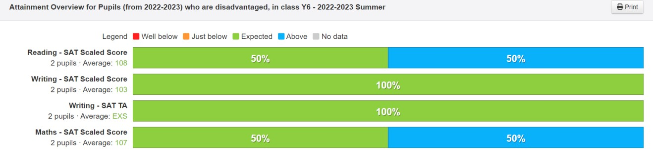

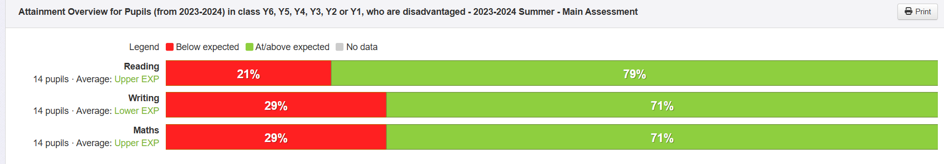

Externally provided programmes
Programme | Provider
ReadWriteInc | Oxford Press
Maths teaching for mastery  NCETM – mastering number  Leadership Briefings  Subject leader training  EYFS leadership network | NorthWest Hub, LLG Partnership, National College, Local Authority

Service pupil premium funding
Measure | Details
How did you spend your service pupil premium allocation last academic year? | The Service Pupil Premium from the last academic year was included in the spending for all pupil premium provision due to the very small number of children who are allocated this funding.
What was the impact of that spending on service pupil premium eligible pupils? | Those children who receive this premium all achieved age related or above expectation last year.

PPG Pupil Voice Survey – July 2024 - KS1 and KS2
Positives
All children spoke positively about school. They were happy to talk about themselves and school and most pleasingly they seem to be growing in confidence as each year progresses.
When asked what was going well for them in school, they were able to talk about the many different strands of school life. Some spoke of their enjoyment for learning and academic lessons with maths, English, art and science all getting an individual mention, and several talked about the enrichment activities that they took part in, for example the residential trips that take place in Year 4 and Year 6 where they had chance to roast marshmallows, canoe and kayak; things that they have not done before.
The vast majority (92%) children had taken part in some sort of club in school which is an increase from the previous year. The clubs named were varied and are cited above.

Children were asked what helped them learn. They said they liked it when teachers spoke slowly and explained things, ‘step by step.’ Several children said that they found focus and concentration a challenge, and enjoyed having an extra adult in the classroom on hand so that they could have help, ’not all the time, just when things get a bit tricky.’ All the children said that felt safe in school and that they enjoyed learning.
One child said that they sometimes found work difficult and this made them angry. Tackling emotions was something that all children recognised as something school have worked on in assemblies, and whilst they thought that school did encourage them to look after their mental health, they did say that it helped to have an adult to talk to when they had those overwhelming feelings.

The push throughout school to improve our book provision has paid off with the vast majority of the children speaking positively about reading, ‘Reading a book is like a holiday in your head,’ was the way one child explained their experience of reading, along with ‘I like it when the teacher reads to us. You can just listen or follow in the book. It makes you feel all lovely.’
We will continue to put the reading curriculum at the very heart of all that we do.

It is pleasing that all of the children were able to talk positively about their wider experiences that school had facilitated in some way. Some spoke of their growing confidence when they had joined the football club, another spoke of her pride that she had taken part in a borough wider concert performance for the very first time. Many spoke of their progress in academic subjects, such as English.
Perhaps most positively, several children were able to talk about their development in those ‘life’ qualities which we have tried so very hard to encourage, such as resilience, perseverance, and confidence. ‘I stuck to learning the violin even when I wanted to give up and now I’m getting better.’

Considerations for development

For the first time, children have been far more in tune with their mental health and the challenges that they face.
Some recognised that they found it hard to manage their emotions, and found it comforting to have someone to talk to who could help them navigate their way through any emotional turmoil. School are aiming to employ a new pastoral lead once again which will help with this.

